Practical 3: Implement WordCount problem using Hadoop MapReduce in Eclipse: (Without Combiner & With Combiner)

Steps involved how to Implement WordCount problem using Hadoop MapReduce in Eclipse: (Without Combiner & With Combiner) below in the following order-
Step 1 - Open virtual box and then start cloudera quick start.
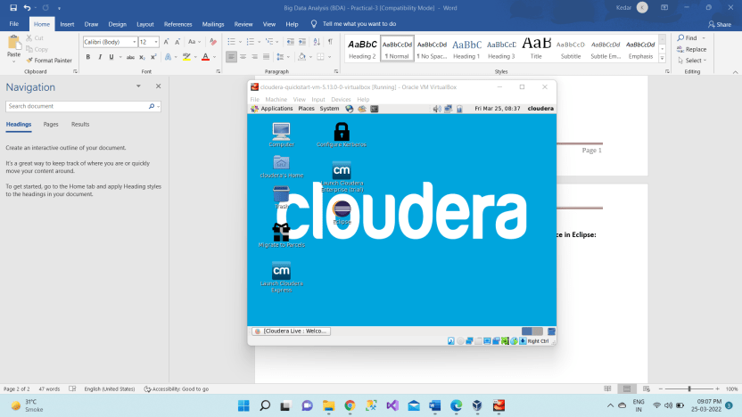
Step 2 - Open Eclipse present on the cloudera desktop
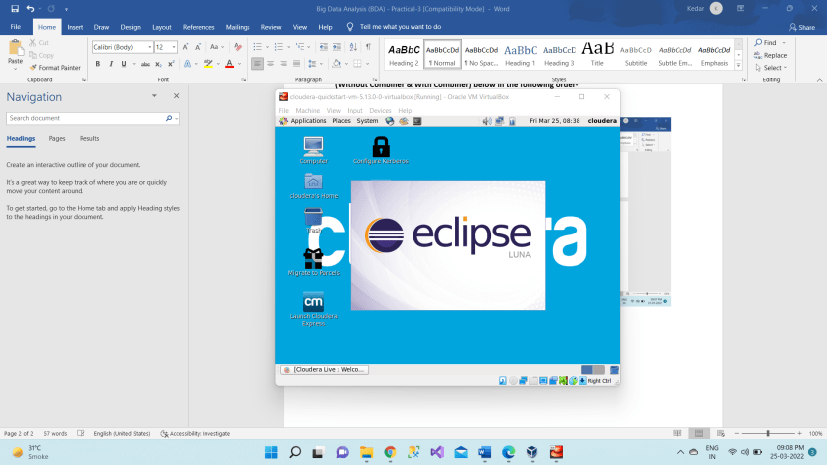
Step 3 - Create a new Java project clicking: File -> New -> Project -> Java Project -> Next (“WordCount” is the project name).
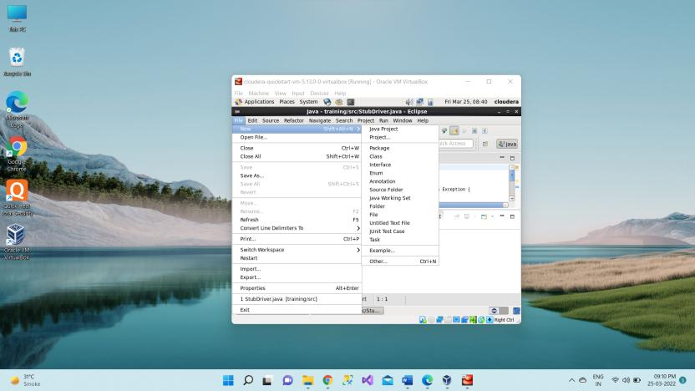
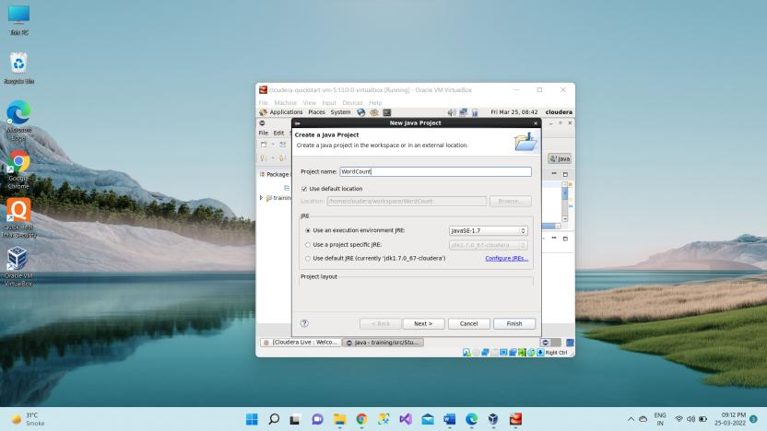

Step 4 - Adding the Hadoop libraries to the project Click on Libraries -> Add External JARs Click on File System -> usr -> lib -> hadoop Select all the libraries (JAR Files) -> click OK Click on Add External jars, -> client -> select all jar files -> ok -> Finish
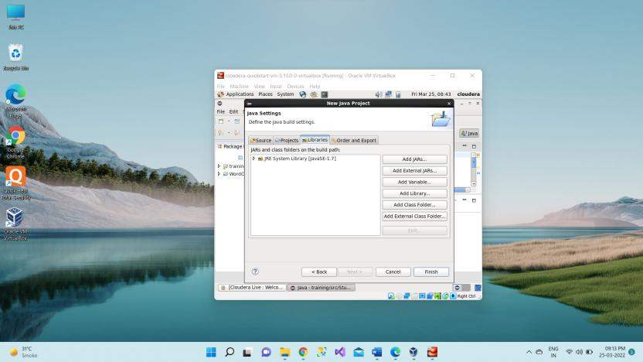
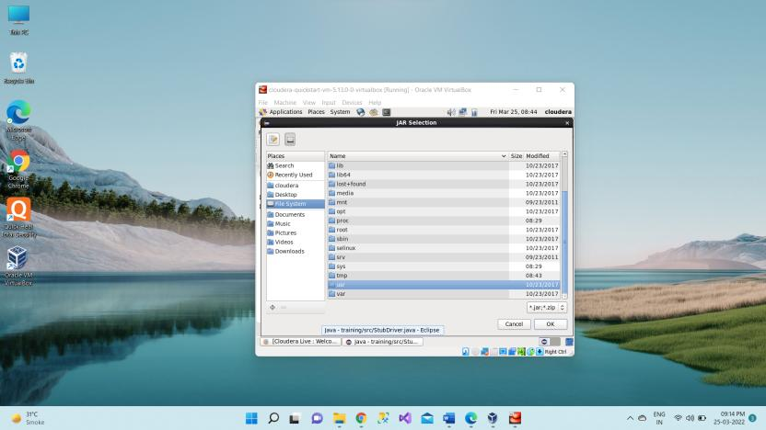
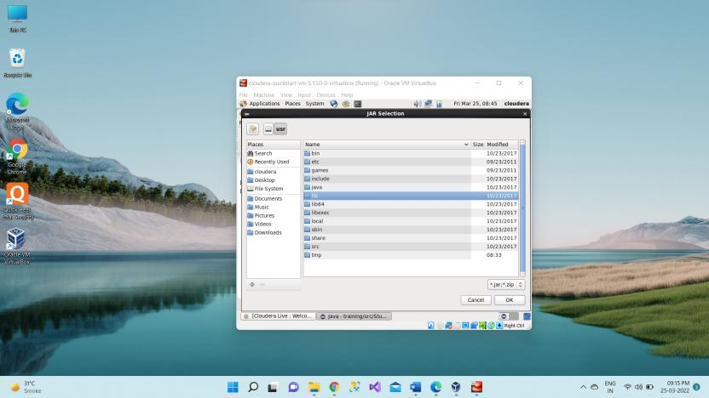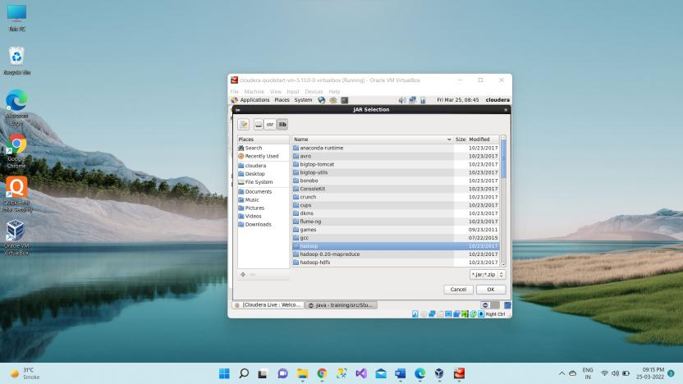
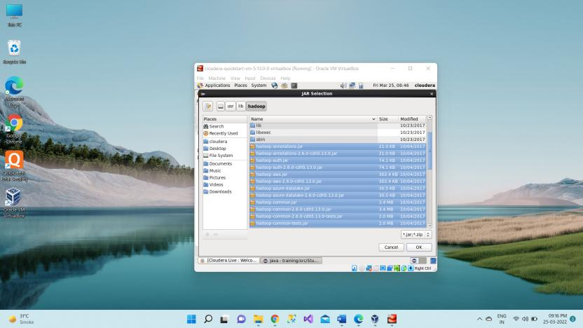
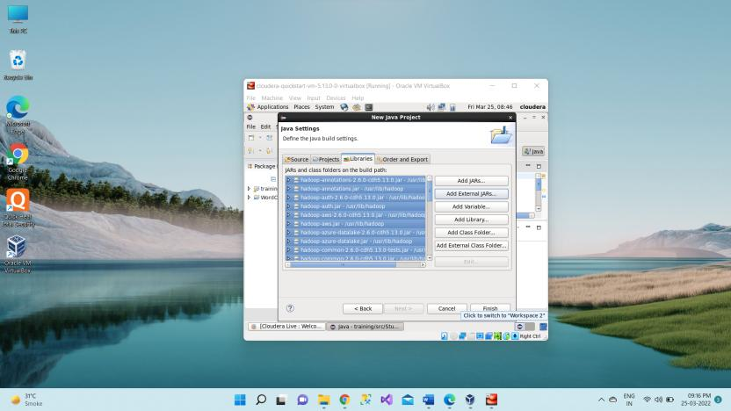
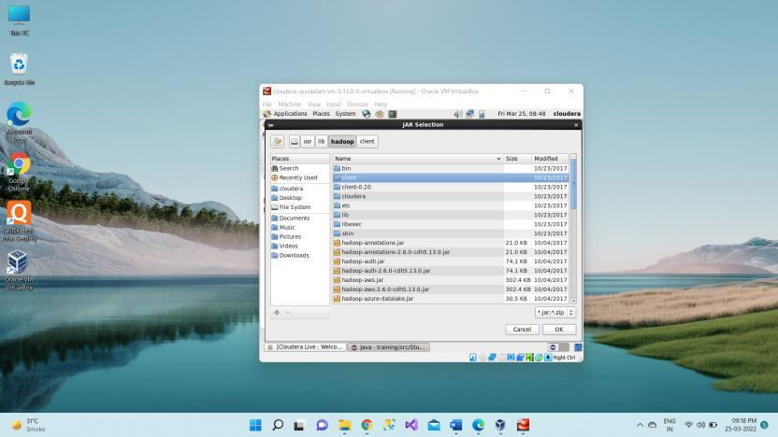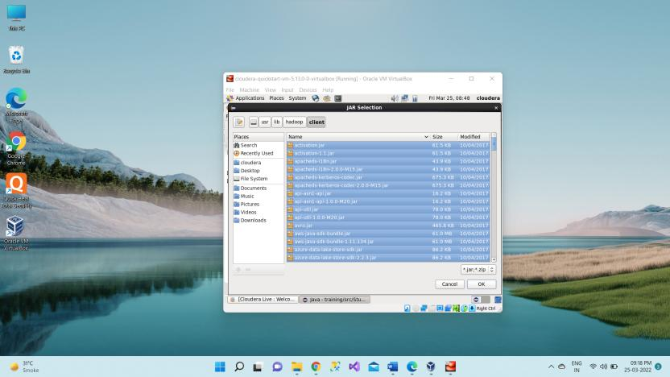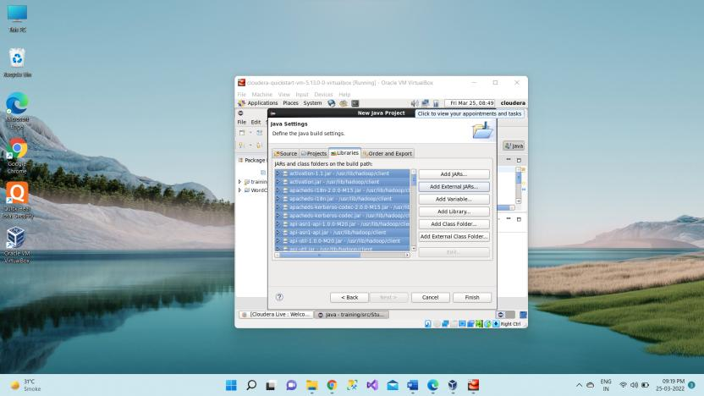
Step 5 - Right Click on the name of Project “WordCount” -> New -> class Don’t write anything for package Write Name Textbox write “WordCount” -> Finish Then WordCount.java window will pop up
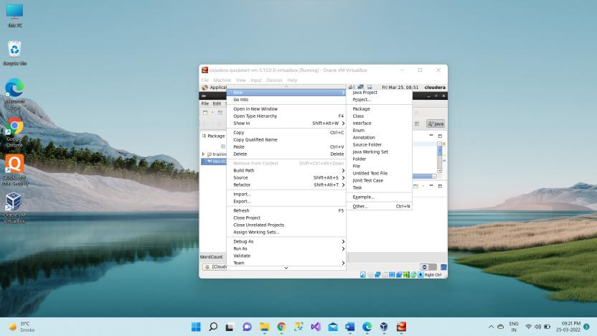
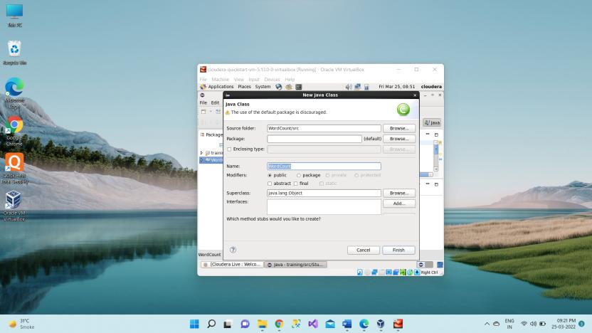
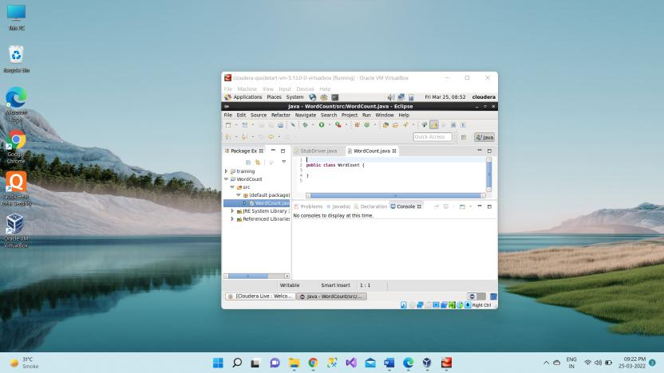
https://hadoop.apache.org/docs/r3.1.1/hadoop-mapreduce-client/hadoop-mapreduce-client-core/MapReduceTutorial.html#Source_Code
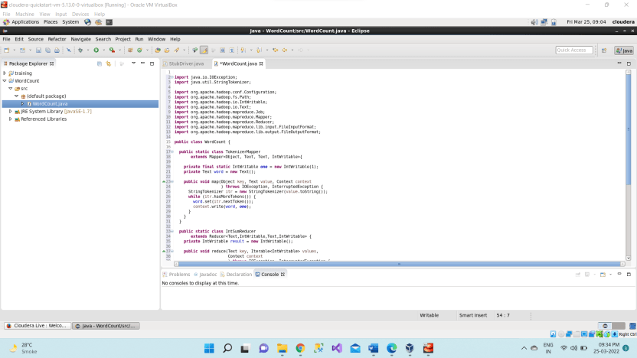
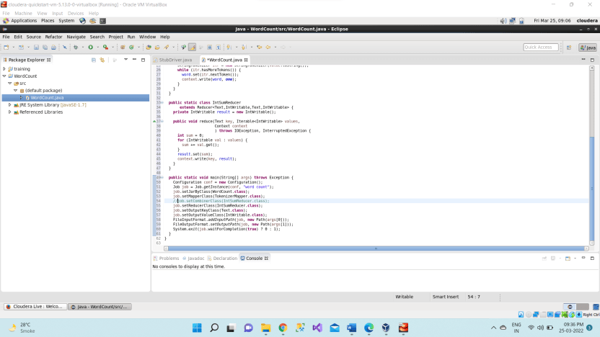
Main function We are running the code without combiner. That is why we commented the combiner line in main function.

Step 6 - Right Click on the project name WordCount -> Export -> Java -> JAR File -> Next -> for select the export destination for JAR file: browse -> Name: WordCount.jar -> save in folder -> cloudera -> Finish -> OK
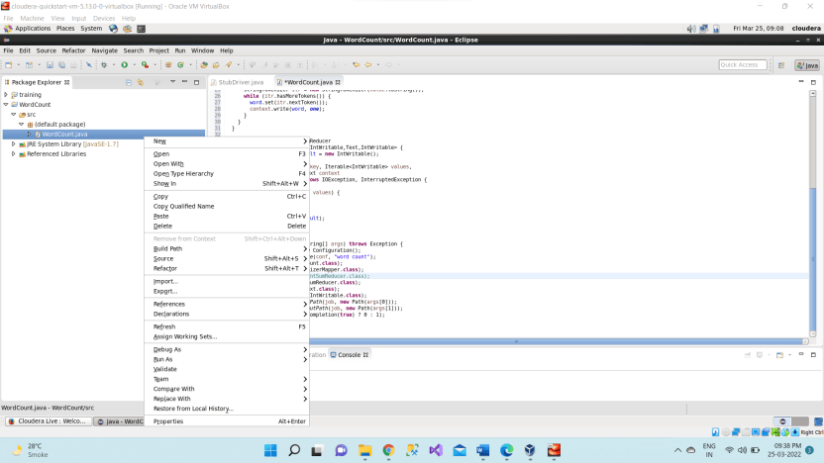
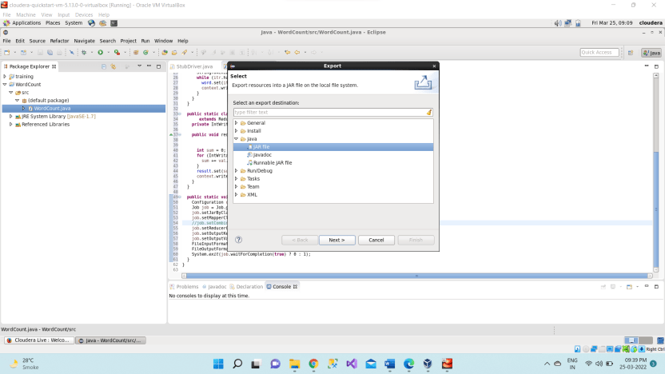
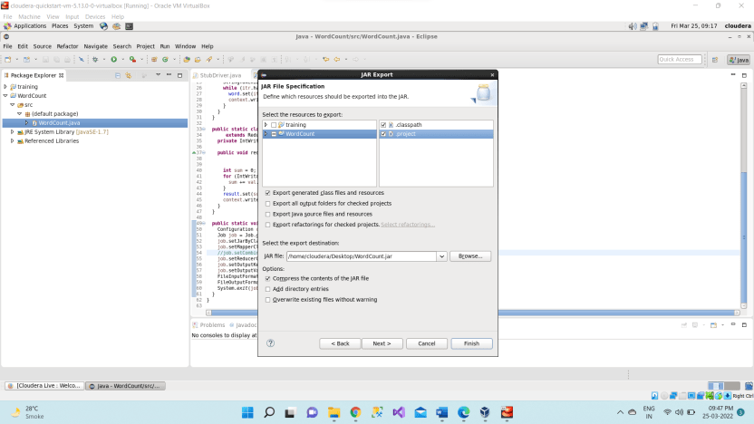
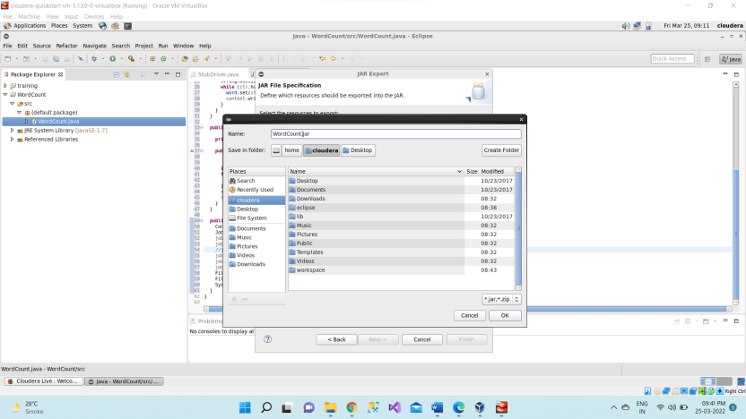
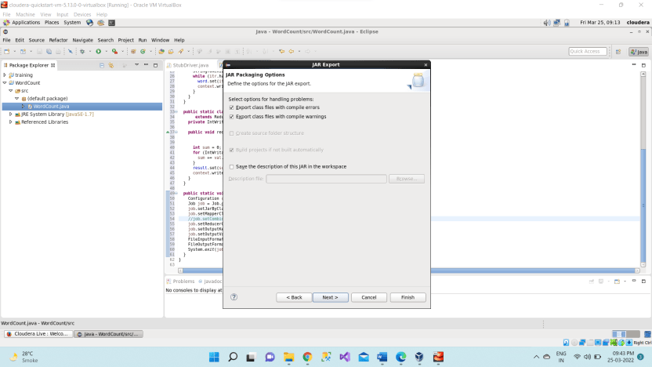
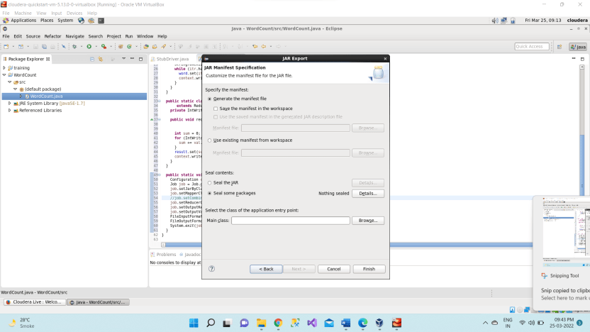

Step 7 - Verify jar file from terminal by using Open terminal & type “ls” There it will show WordCount.jar Check current working directory ->pwd
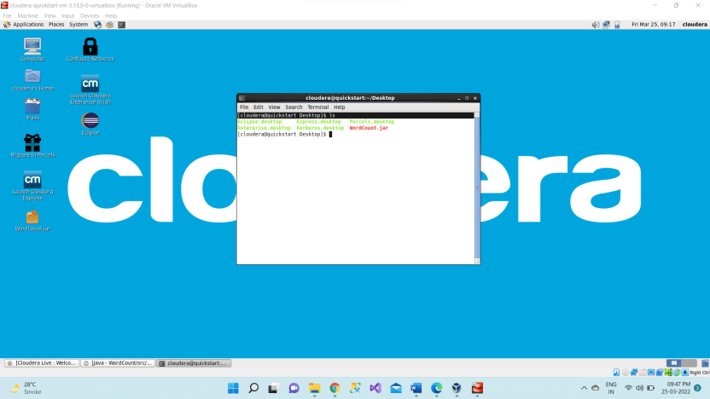
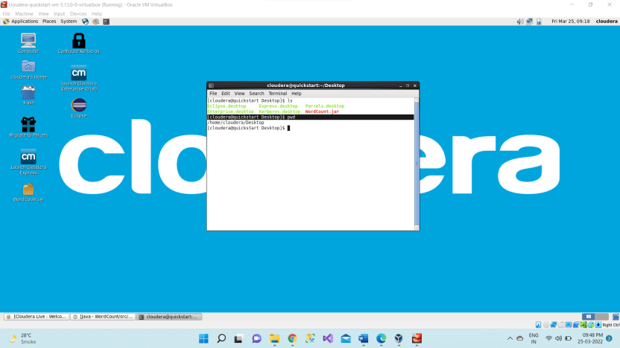

Step 8 - We need to create an input file in local file system Creating an input file named as “abc”.
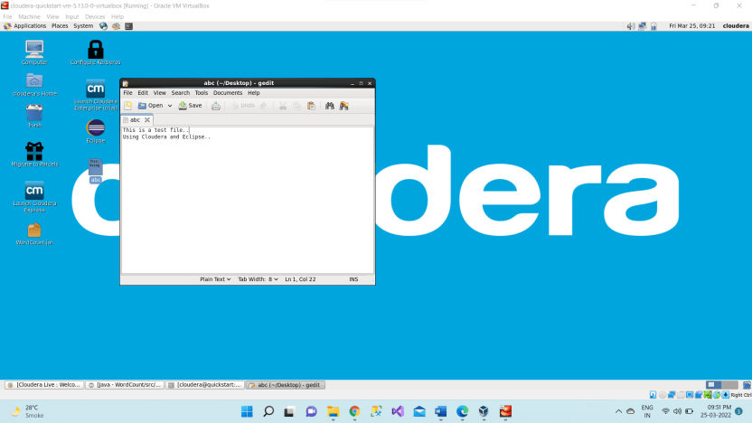
Here listing all the directory present in hdfs using hdfs dfs -ls / command
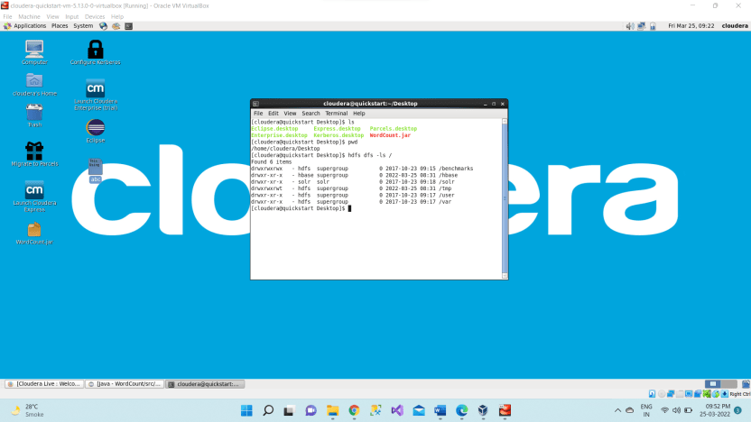
Step 9 - Now we have to move this input file to hdfs. For this we create a direcory on hdfs using command hdfs dfs -mkdir /inputnew.
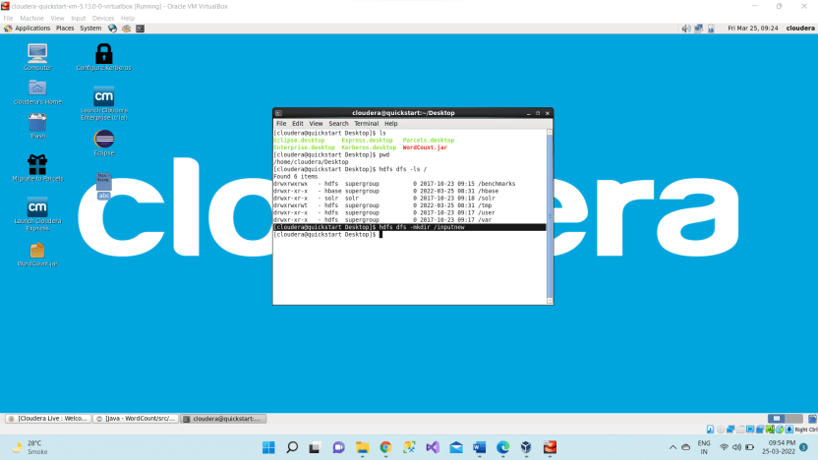
Then we can verify whether this directory is created or not using ls command hdfs dfs -ls /
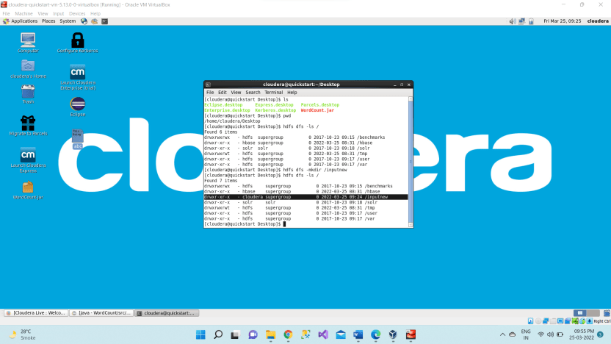
Step 10 - Move the input file to this directory created in hdfs by using either put command or copyFromLocal command
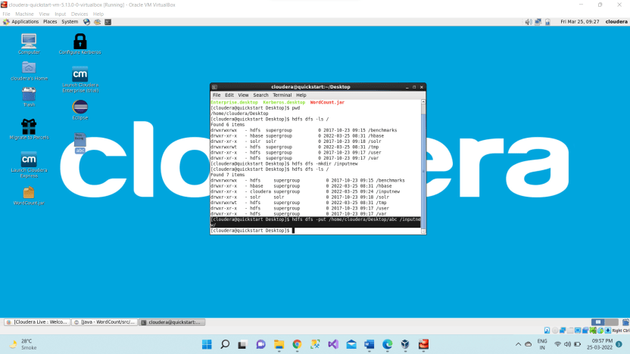
Now checking whether the “abc” present in /inputdir directory of hdfs or not using hdfs dfs -ls /inputdir command
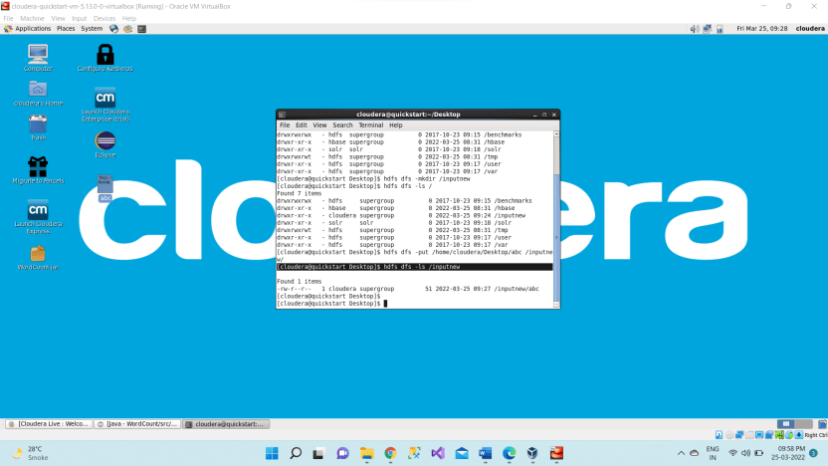
Step 11 - As we can see “abc” file is present in /inputdir directory of hdfs. Now we will see the content of this file using hdfs dfs –cat /inputdir/abc command
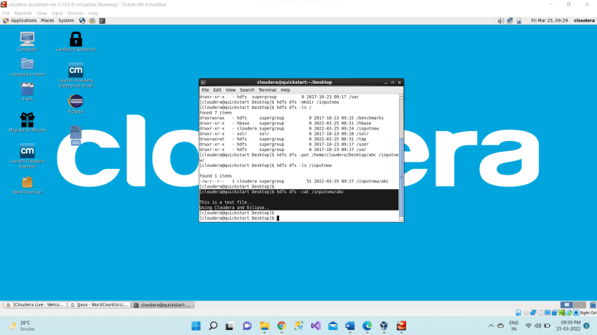
Step 12 - Running Mapreduce Program on Hadoop, syntax is hadoop jar jarFileName.jar ClassName /InputFileAddress /outputdir
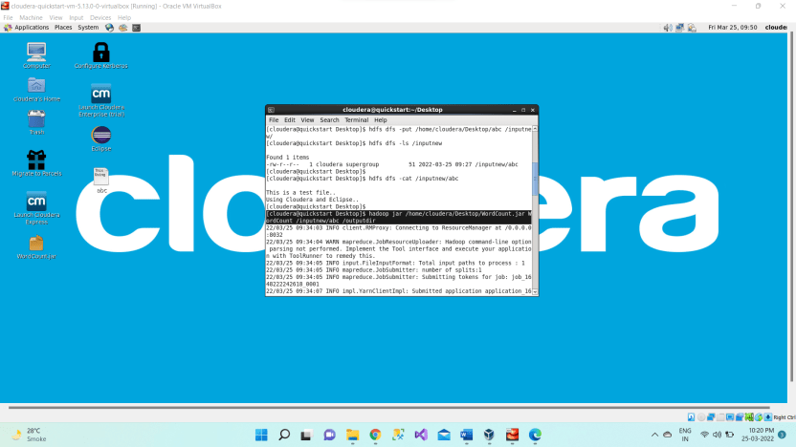
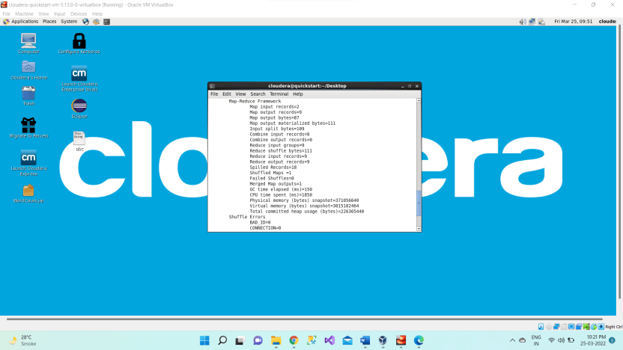
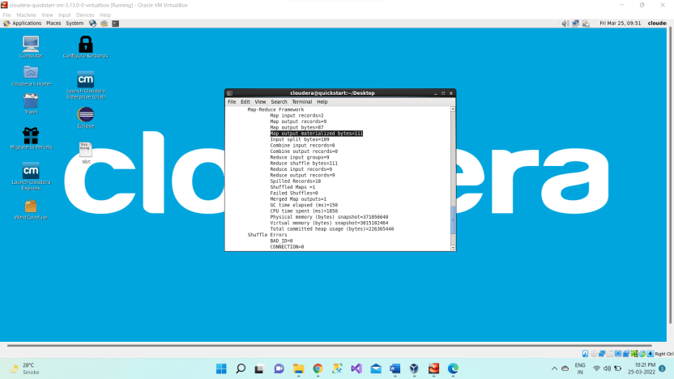
So, when we are not using combiner 1876 bytes acting as an input for the reducer.

Step 13 - Then we can verify the content of outputdir directory and in that part-r file has the actual output by using the command Hdfs dfs -cat /outputdir/part-r-00000 This will give us final output.
The same file can also be accessed using a browser. For every execution of this program, we need to delete the output directory or give a new name to the output directory every time.
1st we are checking whether the outputdir directory is created in hdfs or not using command hdfs dfs -ls /
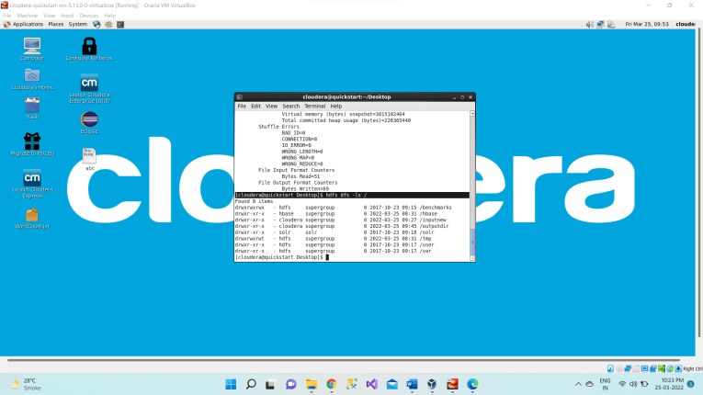
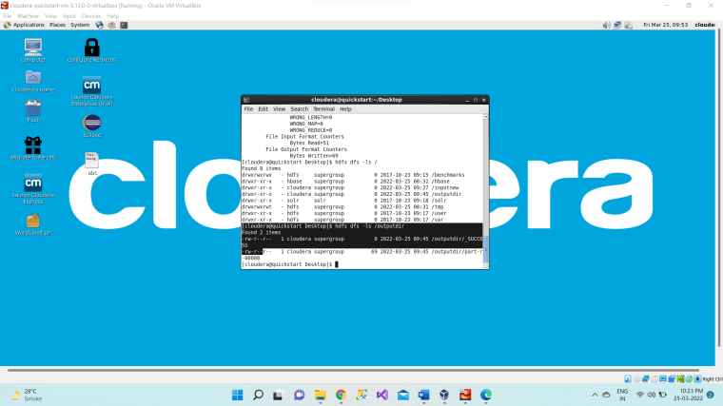
Now we want to read the content of the part-r-00000 file which present inside the outputdir using command hdfs dfs -cat /outputdir/part-r-00000
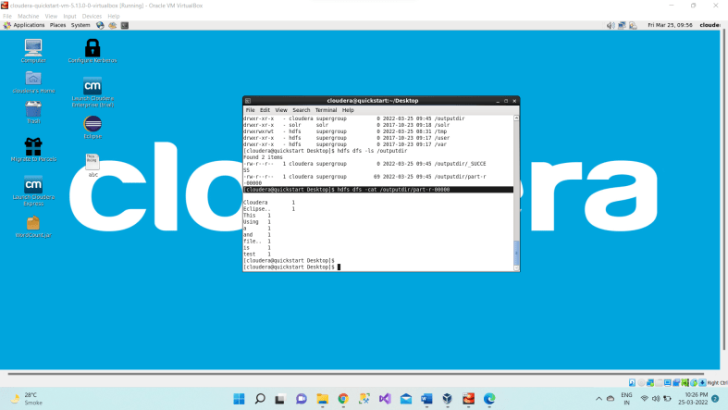
It will give the count of number of times each word has occurred as output.
Step 14 - The same file can also be accessed using a browser. Browse the Directory by Hadoop->HDFS Namenode->Ultilities ->Browse the file system
